In Motion Bultaco UK
213 Pooley Green Road, Egham, Surrey, TW20 8AS, UK
Tel: 01784 440033 Fax: 01784440048
www.inmotiontrials.com
Email: info@inmotiontrials.com

WIRING INSTRUCTIONS FOR ELECTRONIC BULTACO TRIALS IGNITION SYSTEM

BLACK Wire to stator
BROWN Wire to earth
RED Wire to HT coil (black spade)
BROWN Wire to earth
WHITE wire is for a cut out or kill switch.
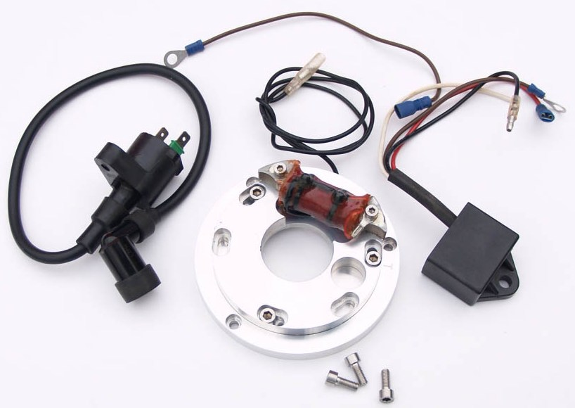
Wiring details:
- Connect the BLACK wire from the stator/generator to the BLACK wire from the CDI box.
- Connect the BROWN wire from the CDI box to earth.
- Connect the RED wire from the CDI box to the BLACK spade on the HT coil.
- Connect the BROWN wire with a 6mm ring terminal to the GREEN spade on the HT coil
And the 6mm ring terminal to earth.
If you are fitting the kit with lights-
The RED wire from the aluminum coil/lighting relay should be wired to a distribution block as it feeds the entire lighting circuit.

The WHITE wire is for a cut out or kill switch. When this wire is earthed
the ignition is cut off. The spark plug gap setting should be 0.4mm.

This ignition comes with a 1 year warranty.

PLEASE NOTE: Please DO NOT adjust the inner stator plate as the ignition is pre set. There is no need to use a strobe light or adjust anything at all, just fit stator, wire up as above and start your bike!

